Group 6

Michael Barre

Zion Mantey

David Mendoza

Assignment 5 – Inode Traversal

Inode from system command

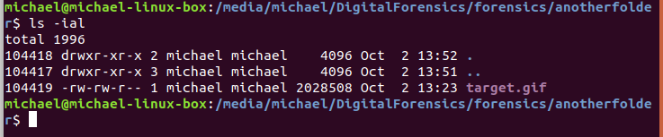

Output from inode command

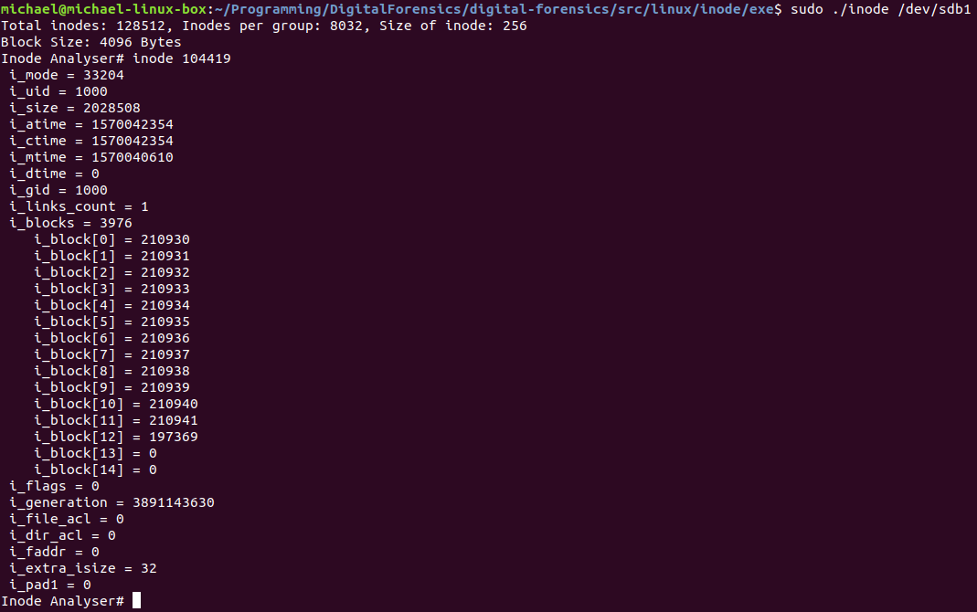

Output from our code

